# Ex. No. 1

**INSTALLATION OF VIRTUAL MACHINE IN VIRTUAL BOX**

# AIM:

To configure a Virtual Machine using Virtual Box and Launch to execute a simple program

# PROCEDURE:

1. Launch a Virtual Box
2. Create new virtual machine
3. Customize the set-up
4. Set username and password
5. Browse for .iso file of an operating system
6. Configure the hardware capacity
7. Finish and power on the VM
8. Install C or PYTHON OR JAVA Compiler and execute a simple program

# OUTPUT:

Download and run the VirtualBox installer

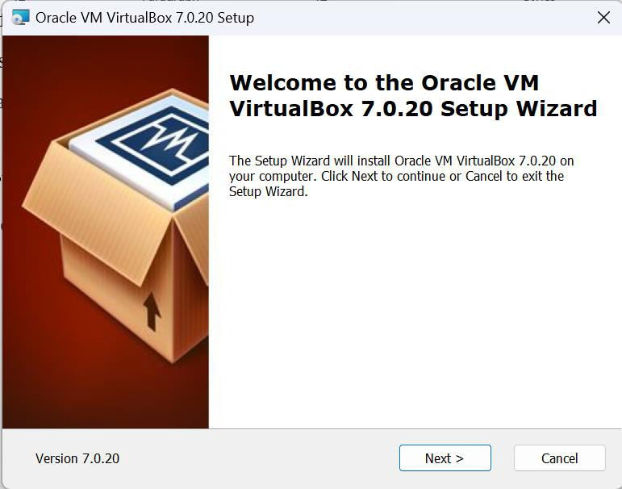

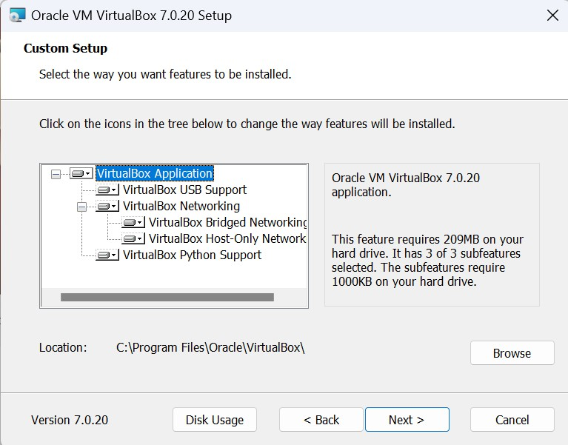

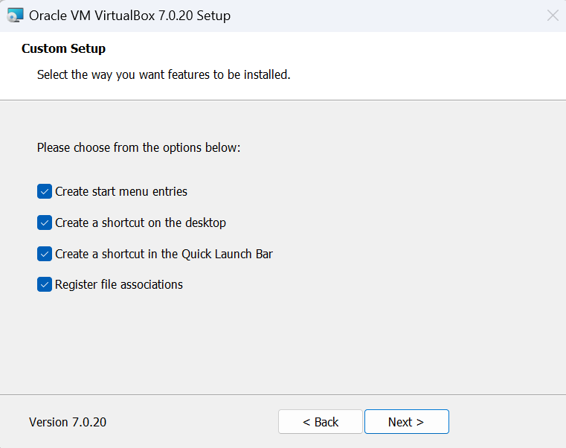

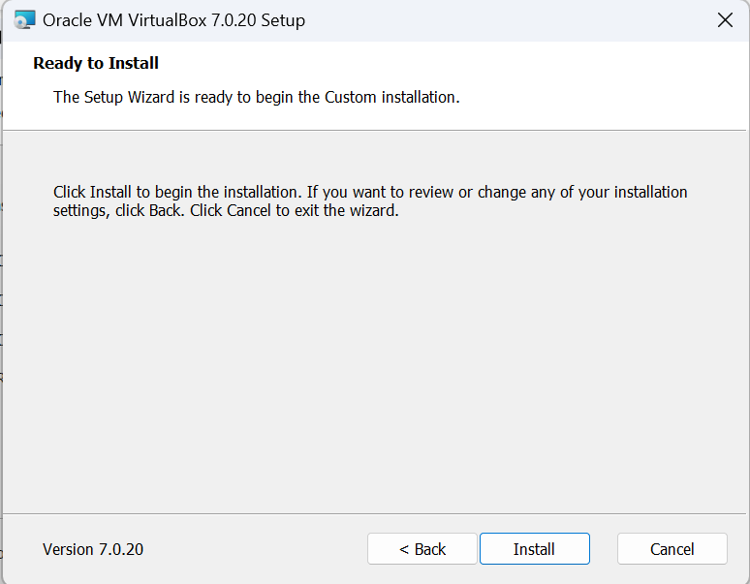

Open Oracle VM VirtualBox

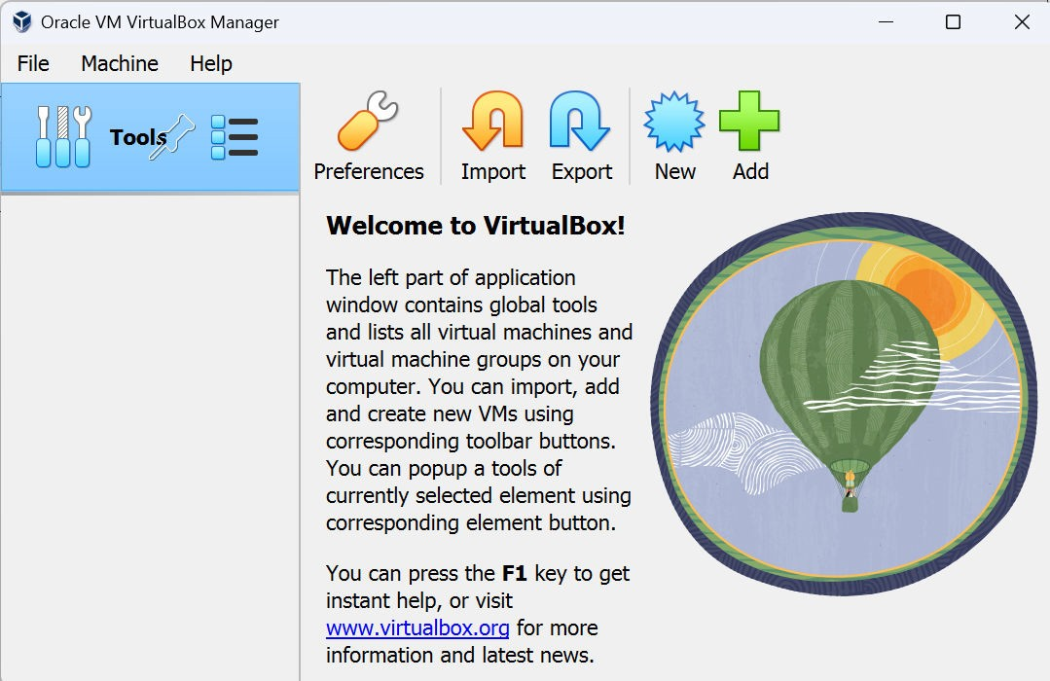

Click on ‘New’ and create a new virtual machine

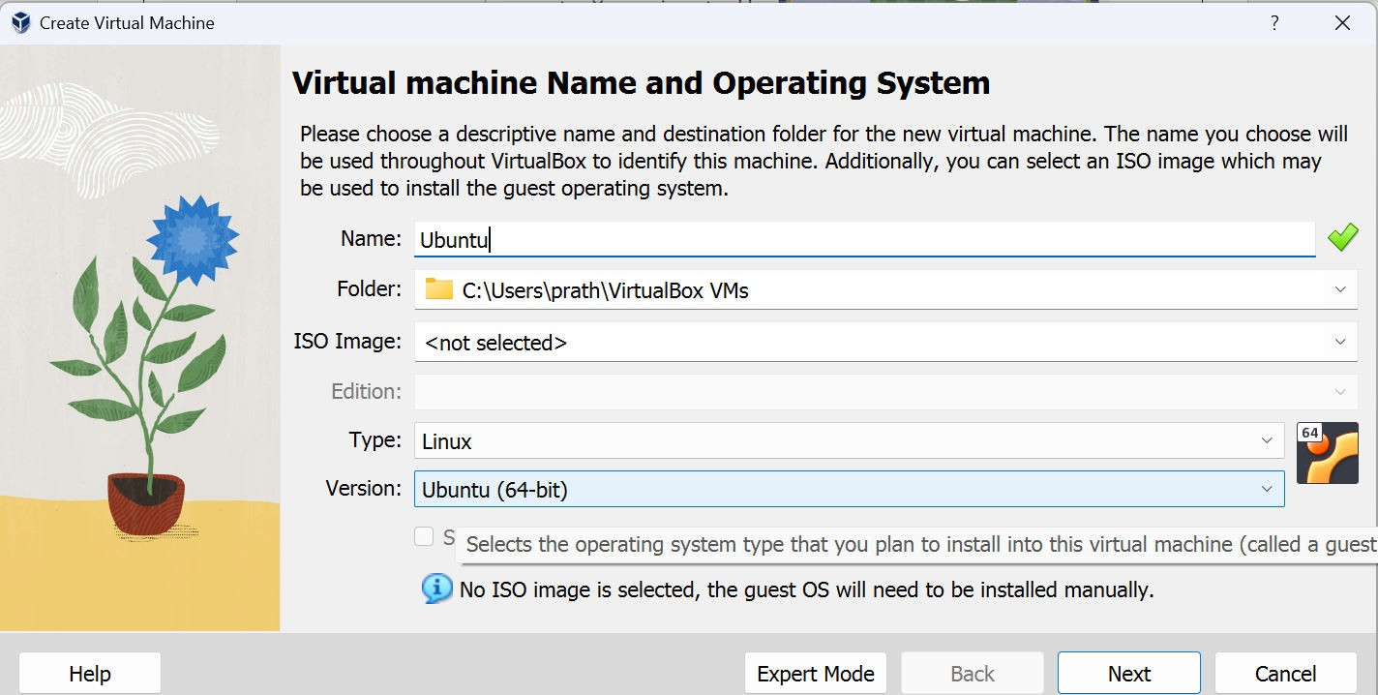

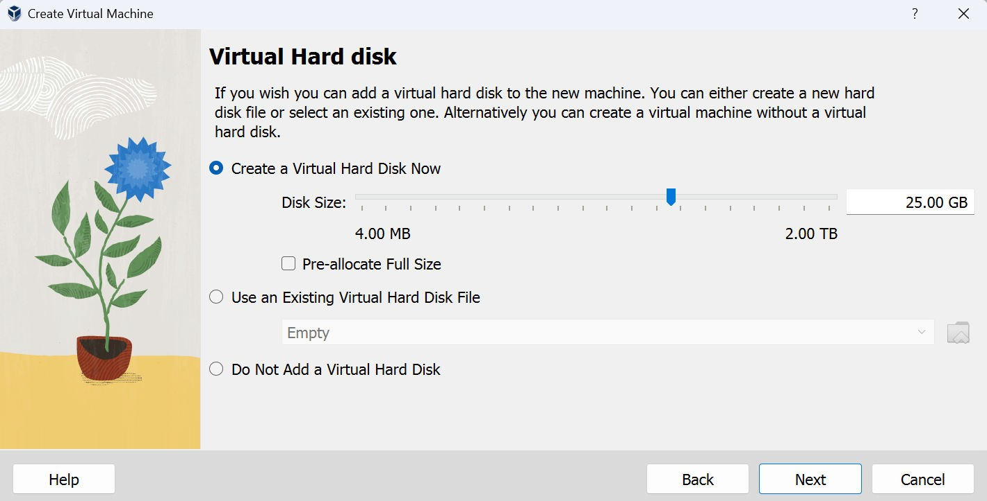

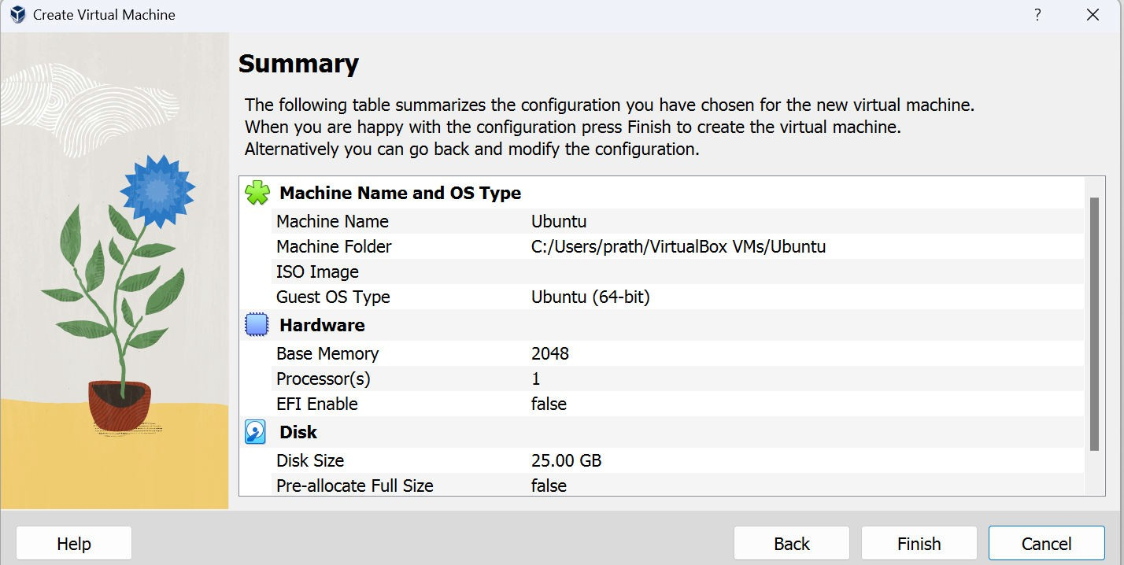

Launch the iso file of Ubuntu operating system into the virtual machine.

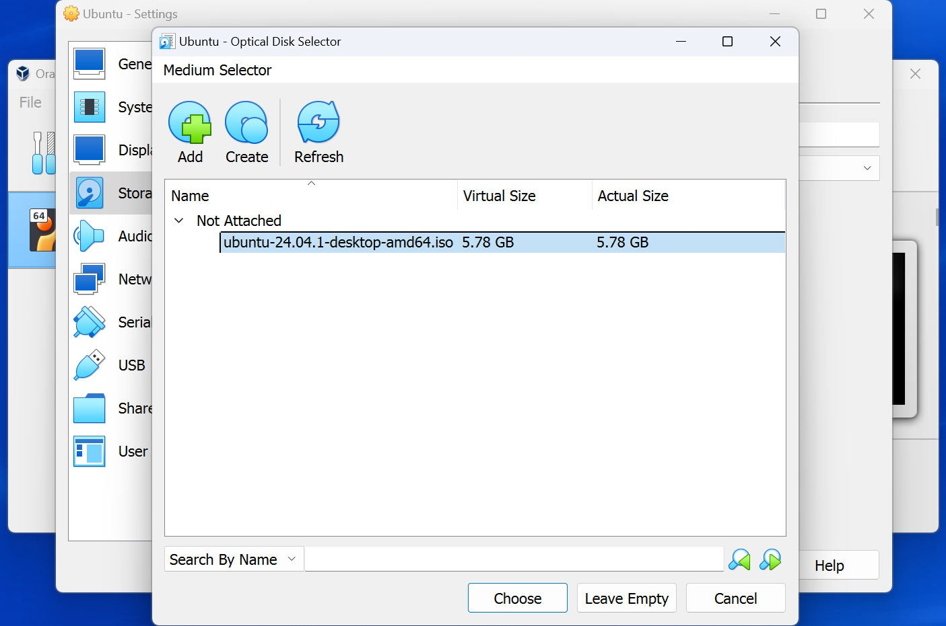

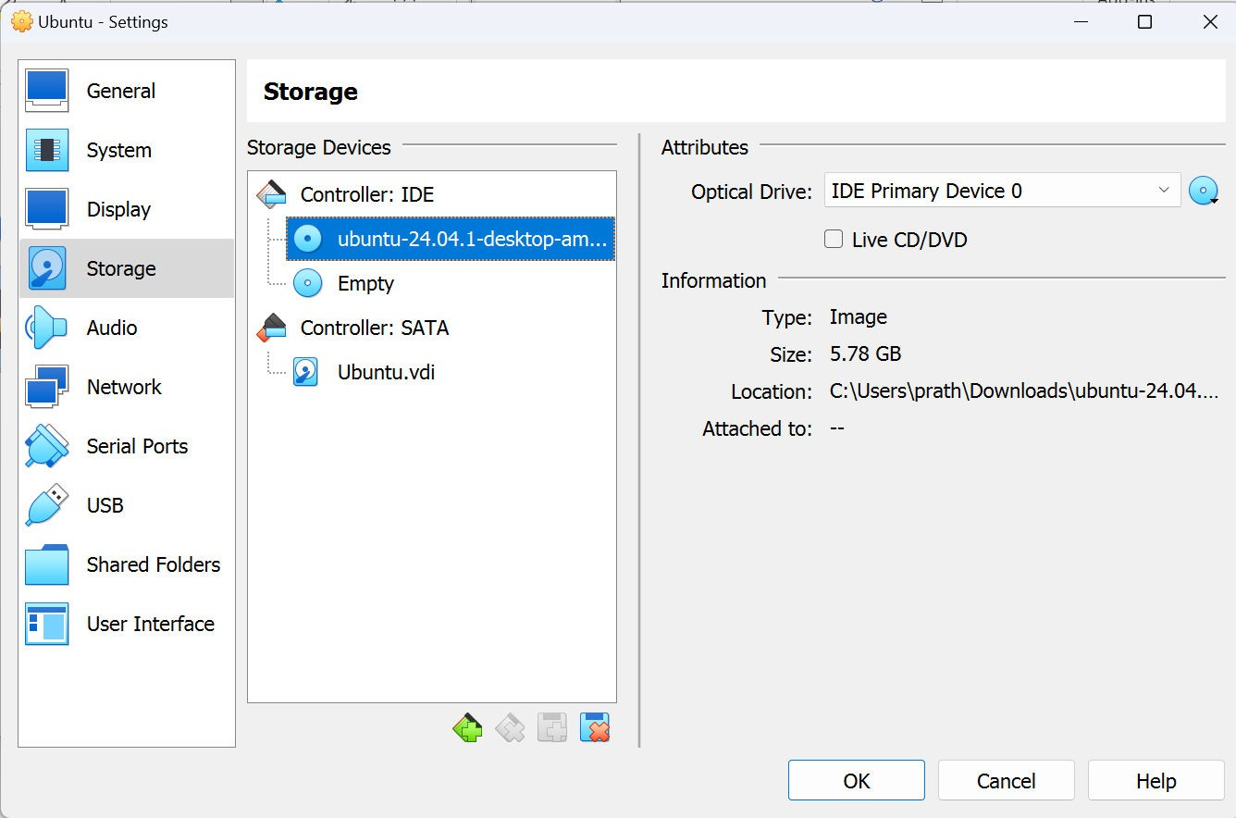

Start the virtual machine

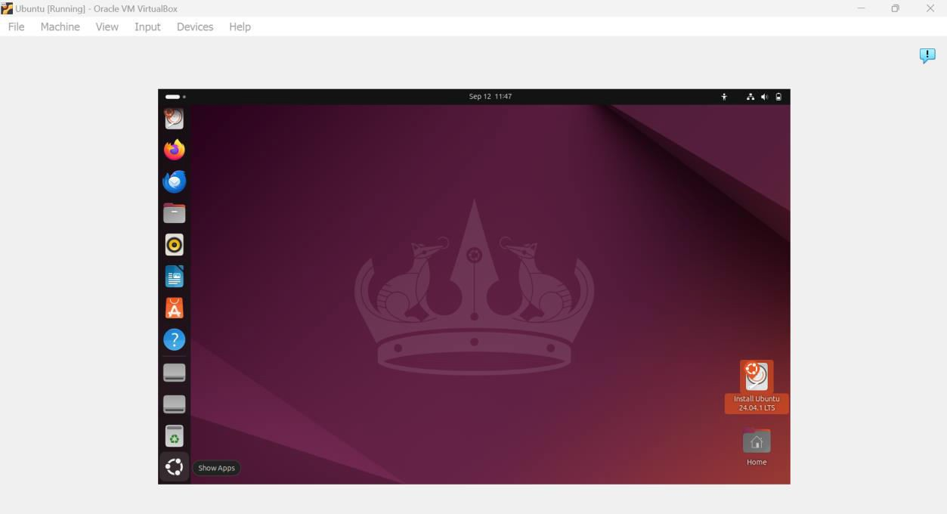

Open terminal and install vim using the command: sudo apt install vim

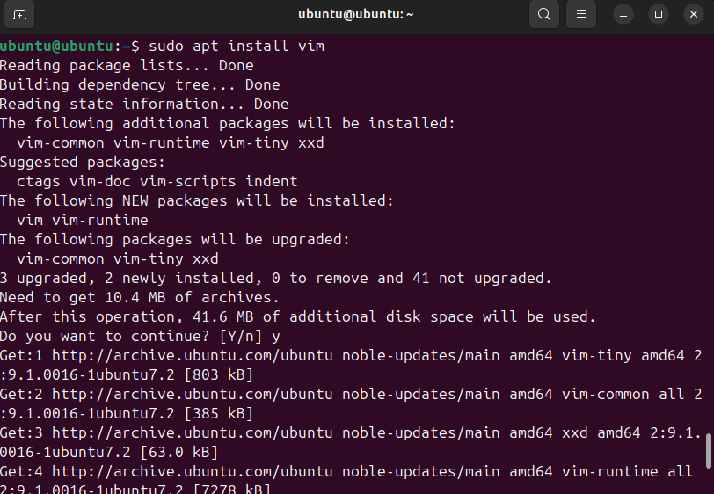

Create a Python program and execute it

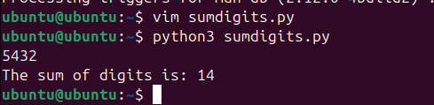

# RESULT:

A virtual machine is created using Virtual Box and a simple program is executed on the virtual machine.